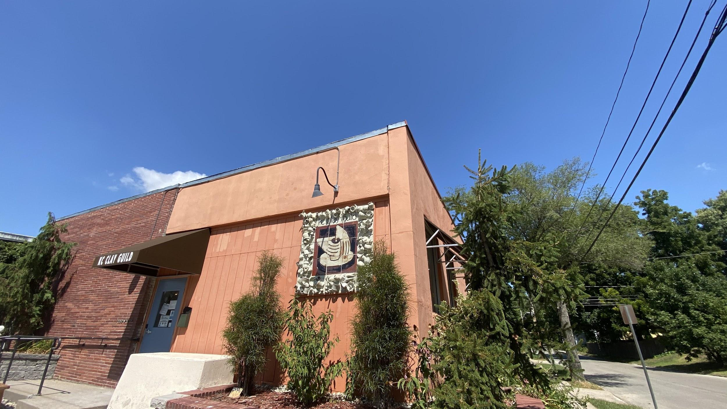

ARTIST IN RESIDENCE HANDBOOK
UPDATED 2/2/2021

KC Clay Guild
200 W. 74th Street
Kansas City, MO 64114
816-363-1373
kcclayguild.org
studio@kcclayguild.org
INDEX

KC CLAY GUILD

About KCCG 3
Hours of Operation and Class Schedule 5
Staff and Contact Info 6

YOUR RESIDENCY AT KCCG

General Information 7
Exit Show 7
Arrival and Departure 7
Housing and Transportation 8
Residency and Studio Privileges 8
Studio Spaces 9
Privacy and Security 10
Resident Responsibilities 10
Teaching and Job Opportunities 10
Artwork Sales 11
Membership 11

FACILITIES AT KCCG

Kilns and Firing 11
Glaze Lab 11
Clay Mixing 12
Tools and Equipment 12
Suggested Items to Bring

SIGNATURE PAGE 13

FAQ 14

APPLY 16 COVID-19 RESPONSE 16
KC CLAY GUILD

ABOUT

KC Clay Guild Inc. (KCCG) was founded in 1988 in the home of potter, Michael Smith. Soon after, KCCG began meeting on the campus of the Kansas City Art Institute. By then a group of approximately 70 artists from the Kansas City area were getting together to educate, purchase materials in bulk, and socialize. Over the years KCCG has grown and evolved. In order to offer classes to the community, KCCG rented a building in midtown for several years. KCCG purchased our current building in the Waldo Neighborhood of Kansas City, Missouri in 2000.

KC Clay Guild now functions as a non-profit ceramic arts center. KCCG offers class for all skill levels and ages, a fully equipped ceramics studio, long term artist in residence program, and workshops. KCCG employs a Studio Director (Louis Reilly) to manage many facets of the organization’s operations, but relies heavily on the KCCG volunteers to assist in day to day operations and special fundraising events. KC Clay Guild has a volunteer Board of Directors who establish policy and are responsible for the KCCG’s financial operations.

MISSION STATEMENT

To promote the appreciation of and participation in ceramic arts through group and individual education programs, public outreach and the creation of a diverse ceramic arts community.

ARTIST IN RESIDENCE PROGRAM HISTORY

Like KCCG in general, the KCCG AIR program has also evolved. Before the program took its current form, KCCG had a Studio Technician and one AIR. In this earlier arrangement, the Studio Technician and AIR worked together to fire kilns, prepare materials, and maintain the studio in exchange for studio and kiln space.

In 2015 KCCG created the Studio Coordinator position, the organization’s first paid manager. Along with this position, KCCG shifted to offering two AIR positions and added an annual stipend to the program. KCCG’s current AIR program has three positions.

The KC Clay Guild Artist in Residence Program is designed to provide emerging and established ceramic artists an opportunity to further develop their professional artistic career through a concentrated and focused residency experience. Residents are encouraged to learn and grow through their own studio practice, participation in the day to day operations of KCCG’s bustling community studio, and general exposure to the greater Kansas City ceramics community.

HOURS OF OPERATION

Monday-Thursday 10am-9pm
Friday and Saturday 10am-10pm
Sunday 1pm-5pm
SCHEDULE OF RECURRING CLASSES

Monday 10am-1pm, Hand Building with Amy Meya*
Monday 6pm-9pm, Wheel Throwing with Todd Scholtz
Tuesday 10am-1pm, Wheel Throwing with Alex Watson
Tuesday 6pm-9pm, Wheel Throwing with Alex Watson
Wednesday 10am-1pm, Wheel Throwing with Louis Reilly
Wednesday 6pm-9pm, Wheel Throwing with Alex Watson
Thursday 10am-1pm, Advanced Wheel Throwing with Cathy Broski
Thursday 6pm-9pm, Advanced Wheel Throwing with Anne Mulvihill
Friday 5:30pm-8:30pm, Wheel Throwing with an AIR*
Saturday 10am-1pm, Wheel Throwing with Abby Callaghan
Saturday 1pm-4pm, Hand Building with Joe Smith
Saturday 1:30pm-3pm, Youth Wheel Throwing with Kelsie Herron*
Sunday 5pm-8pm, One Time Wheel Throwing with an AIR

*Temporary schedule change due to COVID-19.

STAFF AND CONTACT INFO

KC CLAY GUILD

816-363-1373

STUDIO DIRECTOR

Louis Reilly, 314-960-7783, studio@kcclayguild.org

BOARD OF DIRECTORS

Josh Wood, President, 913-544-5775, opeswood@yahoo.com
John Devaney, Vice President, 913-579-9460, jmfdevaney@gmail.com
Melynda Steward, Treasurer, 913-908-1328, adnylemdrawets@gmail.com
Chanda Baker, Secretary, travelchanda@gmail.com
Janet Reuss, Membership, janetjohn@jreuss.com
Abby Callaghan, Education, abbyecallaghan@gmail.com
Kelsie Herron, Marketing, kelsieherronceramics@gmail.com
Aimee Adams, Volunteers, aimeeannadams@gmail.com
Susan Speck, Gallery, llywhite54@yahoo.com
Laura Tyler, Workshops, tyler.laura@yahoo.com

YOUR RESIDENCY AT KCCG

GENERAL INFORMATION

An ideal Artist in Residence candidate for KC Clay Guild (KCCG) is an artist ready to jump-start their career in ceramics. Applicants do not need to have any formal education in the ceramic arts, but must demonstrate their passion and interest for the field. KC Clay Guild is a community based and member driven nonprofit organization. We will select Artists in Residence that are interested in collaborating with and becoming a member of our thriving community of novice, intermediate, advanced ceramic artists.

DURATION

The residency is 1 year with the possibility of renewal for a second year upon review. Please communicate your interest in continuing for a second year with the Studio Director in December or January of your first year.

FUNDING

Residents receive a $2500 annual stipend that is issued monthly ($208/month). Residents also receive a $150 credit to use for applying to exhibitions, workshops, or conferences. KCCG covers the cost of a NCECA conference pass and lodging during the conference. KCCG will cover the cost of transportation for NCECA if deemed within driving distance.

EXIT SHOW

On the first Friday in July the AIR Exit Show will be held for all outgoing residents. This could be 1-3 individuals. The organization, title, and reception plans will be discussed and organized by the participating residents and Studio Director. The show will be held at a gallery space in the Crossroads Arts District or KC Clay Guild. A small budget is provided for marketing and reception.

ARRIVAL AND DEPARTURE

FIRST ARRIVAL

The residency begins on August 2. If you can not begin on or before this day, please give notice to the Studio Director as soon as possible after the acceptance of the AIR position. Please arrive during business hours so that we can show you to your studio, create a key fob for you for access to the building, and answer any questions you may have. If you plan to arrive after hours or on a weekend please give the Studio Director notice to make arrangements to meet you.

ORIENTATION

As a new resident at KCCG you will attend an orientation and tour with the Studio Director. At the orientation all incoming residents will be asked to fill out forms, tax documents, set up an annual membership (provided to residents at no cost), and will receive introductory training on the use and upkeep of all studio equipment.

DEPARTURE

The residency ends on July 25. Please plan ahead and give yourself enough time to finish work and clean out your studio. Your studio must be left clean and empty. Holes in walls must be patched, sanded, and painted. Have the Studio Director check your studio before leaving.

After you leave, please stay in touch! We want to see your work and support you even after your residency.

HOUSING AND TRANSPORTATION

KCCG is near a bus stop at 74th and Broadway. Most residents have a car.

Residents are responsible for their own housing and living expenses. There is no on-site housing and residents must make their own housing arrangements. There are many apartments and homes available for rent in the general area. Neighborhoods that often have rentals are: Waldo, Brookside, Midtown, Westport, and Volker. Zillow is a commonly used resource for finding rentals. We are happy to offer advice and assist in your search for housing.

RESIDENCY AND STUDIO PRIVILEGES

Each resident is provided a free private studio space and 24 hour access to the building. Residents do not pay for firings or in stock materials for mixing glazes (except for Mason stains). Residents may use cone 10 recycled clay at no cost, all other clay materials or moist clay are available for purchase at member rates. Residents may order and pay for materials through the KCCG account at Bracker’s or Crane Yard Clay.

The KCCG AIR program is minimally structured. There are no formal critiques or syllabi. AIRs are expected to be self-motivated in regard to their studio practice.

STUDIO SPACES

Studio spaces are all about 10x10 feet and provided to residents for free on a first come, first served basis. Each studio space has shelving and a work surface. We are happy to provide additional shelving or work surfaces as needed. KCCG will provide a wheel as needed. A communal refrigerator, microwave, and electric kettle are available on site. Our entire building was recently outfitted with 5000K (daylight) LED lighting.
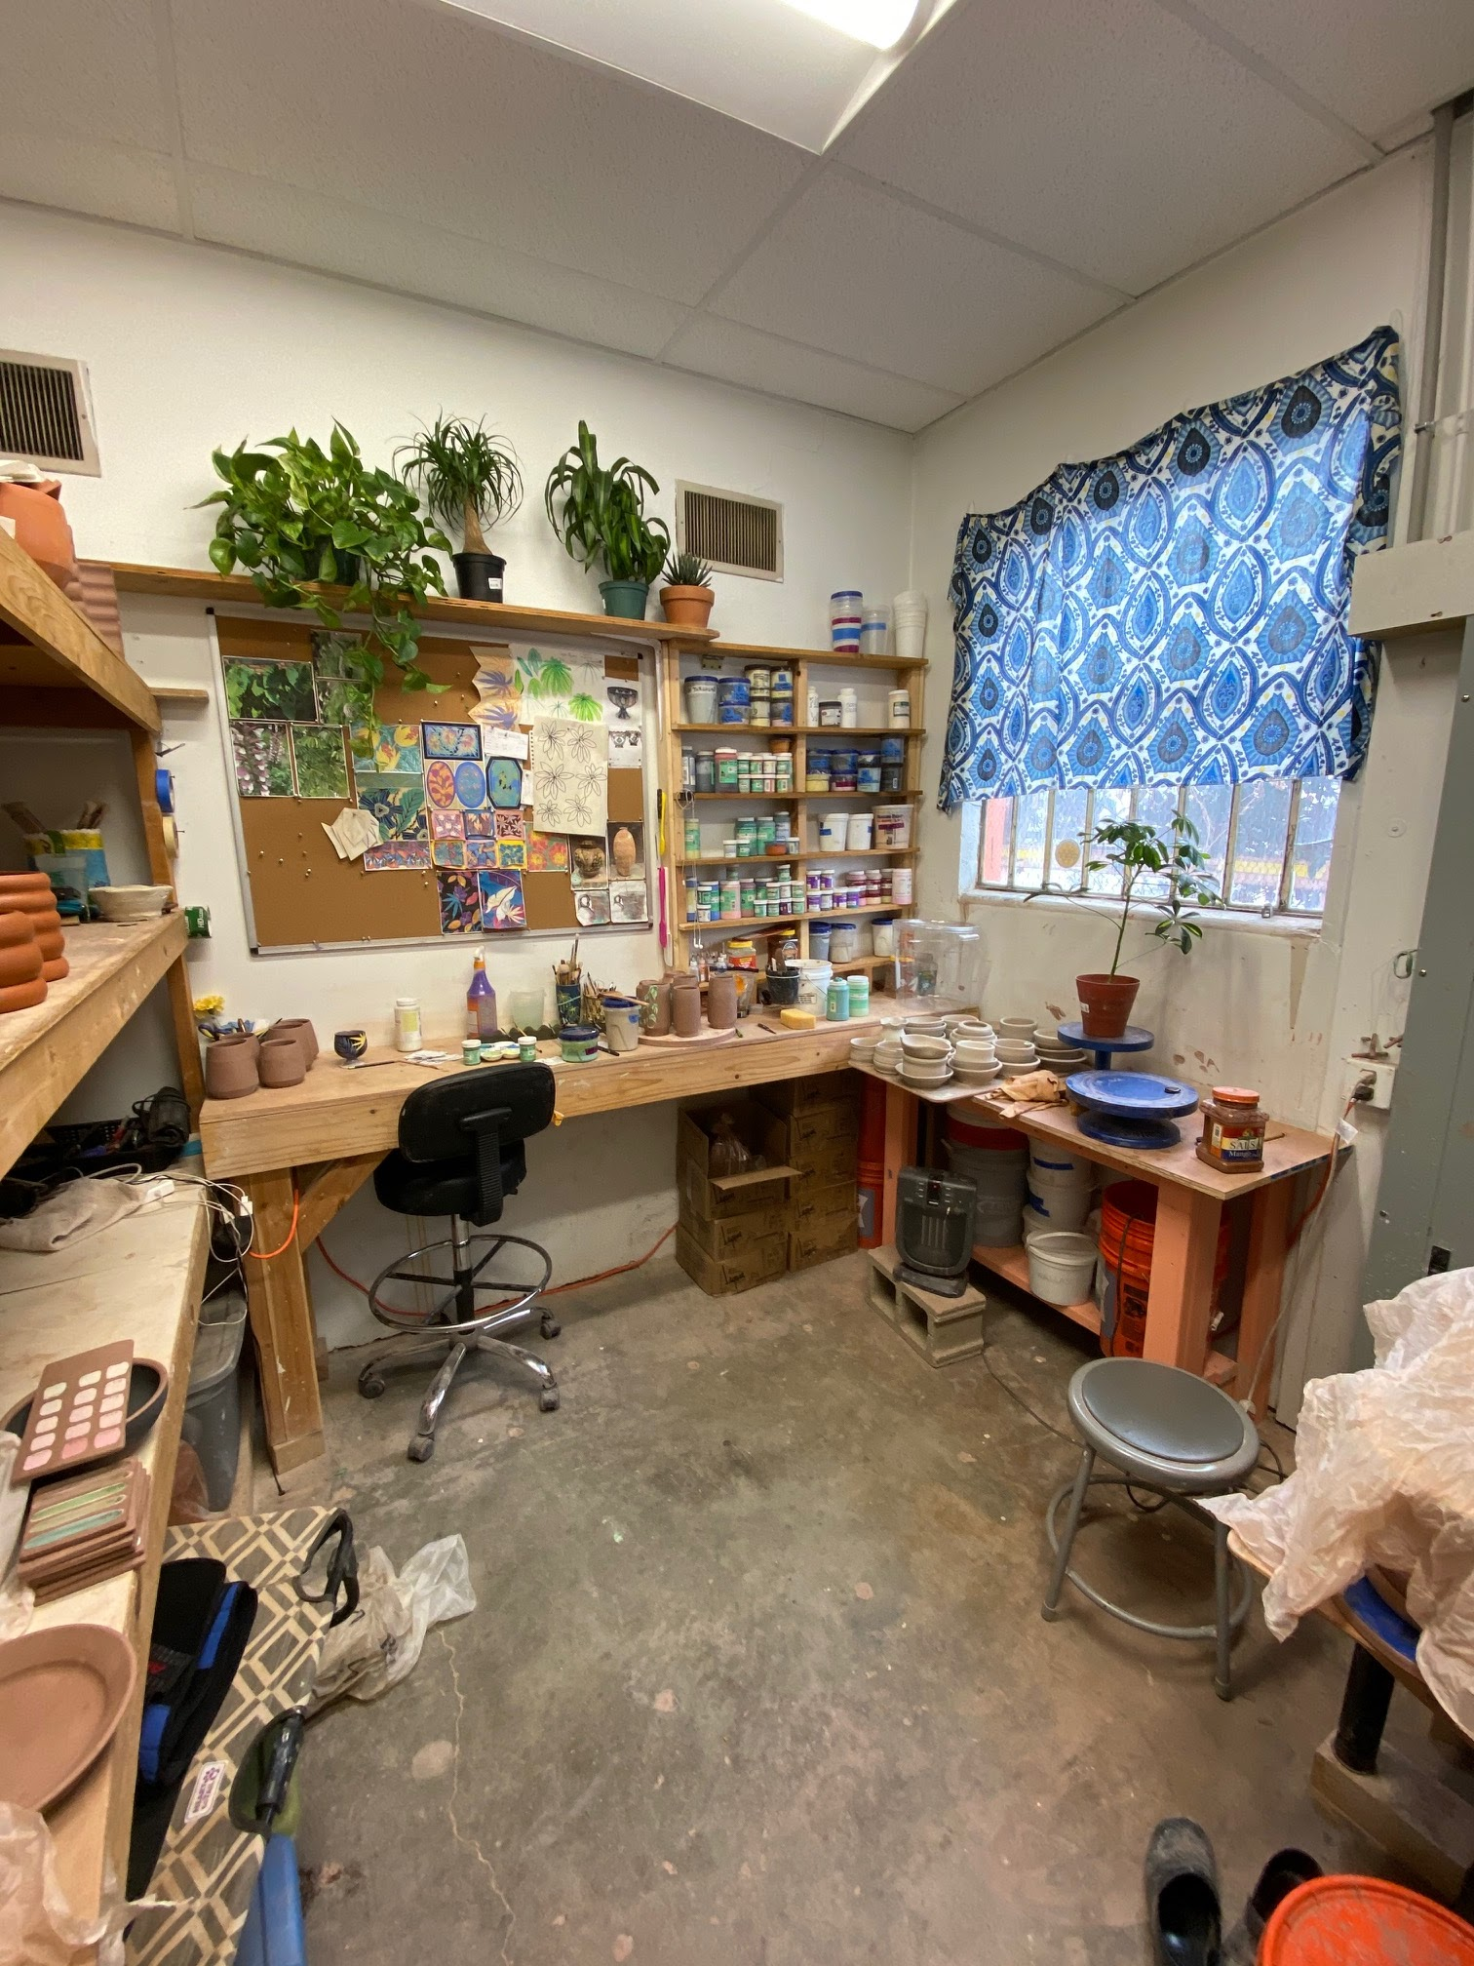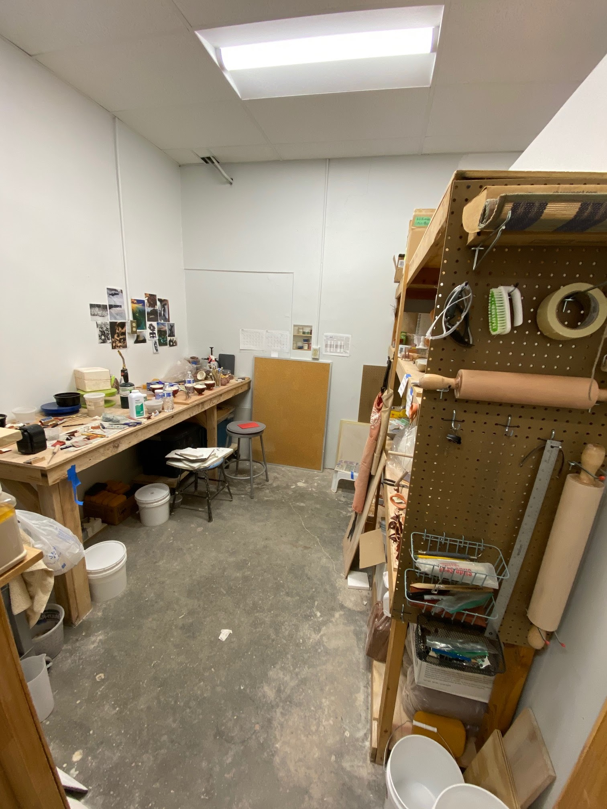

PRIVACY AND SECURITY

Do not enter another private studio space or office without permission. Do not borrow tools or materials from other residents without asking.

Do not leave valuables (laptops, tablets, phones, or expensive tools) in your studio. KCCG is not insured against theft.

RESIDENT RESPONSIBILITIES

Each resident is responsible for working for the studio 12 hours per week. Loading and firing kilns, preparing materials, general maintenance, cleaning, gallery work, and helping out at events are common tasks. KCCG is a busy year round with many students, members, and guests making work every day. We need all 3 residents doing 12 hours each week in order to keep up with the work. Timesheets must be filled out daily to keep track of your hours and tasks completed.

The 3 residents work with the Studio Director as a team to complete all the necessary work for the studio. Tasks are taken by residents on an as needed and first come first served basis. Cherry picking tasks is not allowed.

Communication between the Studio Director and residents will most often be done via group text message.

At the beginning of each month we will meet to discuss how things are going and what is upcoming at KCCG. Mandatory resident meetings occur at 1pm on the first Tuesday of each month.

Quarterly individual check-ins with Studio Director will be scheduled.

Residents are required to donate a significant artwork to the KC Clay Guild AIR collection. The piece must have been made during your residency and should reflect your growth during your time at KCCG. We request three options to choose from in order to select a piece that best benefits the collection.

TEACHING OPPORTUNITIES

KCCG offers classes 7 days a week. There are 4-week classes that meet every month, one time classes, private events, and teaching opportunities at schools in our community (AIRs on the Move program). Residents interested in teaching children will find the most teaching opportunities. In addition to existing classes, residents are encouraged to create a topical class. KCCG pays teachers $22/hour.

ARTWORK SALES

Residents are encouraged to make work available for sale in our gallery, Centered Earth Gallery. Artists keep 60% of sales. KCCG hosts two sales each year. The Annual KC Clay Guild Holiday Sale and Studio Tour draws a large audience and residents typically sell many pieces. We also have an Annual Spring Sale that is also a great event.

MEMBERSHIP

Residents will be provided a KC Clay Guild annual membership during their residency and it will be extended by one year after the end of the residency. We hope you stay connected with KCCG!

FACILITIES AT KCCG

KILNS AND FIRING

Residents are allowed to fire any of the kilns at KCCG at no cost.

Since all of the kilns are frequently used for communal firings, residents must schedule firings in advance. Please meet with the Studio Director before you fire any of the kilns for the first time. Safety is paramount! When you have completed a firing, clean, wash, and put away all kiln shelves and furniture and vacuum out the kiln as needed.

- 60 cubic foot downdraft (to be replaced by 24 cubic foot Blaauw end of 2021)
- 30 cubic foot downdraft
- 30 cubic foot downdraft soda kiln
- Skutt KMT-1627 (2)
- Skutt KM-1227
- Skutt KM-1027
- Skutt KS-714

GLAZE LAB

When mixing glazes, use the dust collector and vent hoods in addition to a respirator with P100 cartridge. KCCG will provide you with a 3M respirator and replacement P100 cartridges as needed. In stock glaze materials are free to residents, this does not include Mason stains. Please mix only as much glaze as you will use, make small test batches before committing to a larger quantity.

KCCG does not have a designated plaster lab nor does KCCG provide plaster. Please work with plaster only in your studio space.

CLAY MIXING

KCCG has a Solder Professional clay mixer and a Bluebird Powerstar deairing pugmill. This equipment is primarily used for mixing cone 10 recycled clay, but residents are allowed to mix custom clay bodies using this equipment. The clay mixer, pug mill, and mixing room must be cleaned thoroughly after use. Residents pay current cost for clay materials and manufactured moist clay, contact the Studio Director for pricing.

TOOLS AND EQUIPMENT

The communal spaces at KCCG have an extruder, slab roller, spray booth, compressor, wedging tables, bats, wareboards, and various molds and decorating tools. KCCG has a 24x24 inch light box for photographing small work.

KCCG has a limited number of hand and power tools available for general studio maintenance and resident use. Contact the Studio Director for woodworking tools or assistance.

SUGGESTED ITEMS TO BRING

Banding wheel, sponges, clay tools, extension cords, kiln gloves, glaze drill, spray gun, safety goggles, buckets, hand tools.

ARTIST IN RESIDENCE ACKNOWLEDGES THAT THEY HAVE READ AND UNDERSTAND THE CONTENTS OF THIS MANUAL AND AGREE TO ABIDE BY ITS TERMS.

Artist in Residence _________________________________________Date__________

FREQUENTLY ASKED QUESTIONS

IF I HAVE A QUESTION WHO SHOULD I ASK?
Louis Reilly, our Studio Director will have answers to most questions. If Louis can’t help reference our list of board members, start with Josh. Contact us if you have questions for a past resident.

DO I NEED TO BRING A WHEEL?
No. We have electric wheels that can be kept in resident studio spaces.

WHAT IS THE WEATHER LIKE IN KANSAS CITY?
A true 4 season environment. Very hot and humid in Summer. Mild and beautiful Fall. Occasional snow and ice storms in Winter. Pack for all conditions.

WHAT ARE THE START AND END DATES OF THE RESIDENCY?
August 2-July 25.

WHAT IS THE DURATION OF THE RESIDENCY?
The residency is 1 year with the possibility of renewal for a second year upon review. Please communicate your interest in continuing for a second year with the Studio Director in December or January of your first year.

CAN I LEAVE FOR EXTENDED PERIODS DURING MY RESIDENCY?
KCCG relies on all three of our residents to keep our studio running, but we allow for leave in most circumstances with 30 days advance notice for leave over 5 days.

CAN I BRING MY PET?
Pets are not permitted in the building.

CAN I HAVE A FRIEND WORK IN MY STUDIO?
The studio provided to you is for your use only.

ARE THERE SET HOURS FOR STUDIO USE?
The building is open to residents 24/7. Advance notice will be given if the building is unavailable for some reason.

APPLY

SUBMIT THE FOLLOWING TO STUDIO@KCCLAYGUILD.ORG
- -Letter of interest
- -CV with contact information
- -Contact information for three professional references
- -Artist Statement
- -10-20 images of artwork completed within the last 5 years with list of image descriptions.

COVID-19 RESPONSE

KC Clay Guild takes the safety of our members, guests, and staff very seriously. Since reopening following a citywide shut down, KCCG has done everything we can so slow the spread of the virus. Well-fitting masks are strictly required and programming has been altered to ensure no more than 10 individuals are in our building at a time. A sign in sheet, a health screening form, and a waiver of liability must be completed upon entering the building.

